Lab 6

2) Circuit Diagram

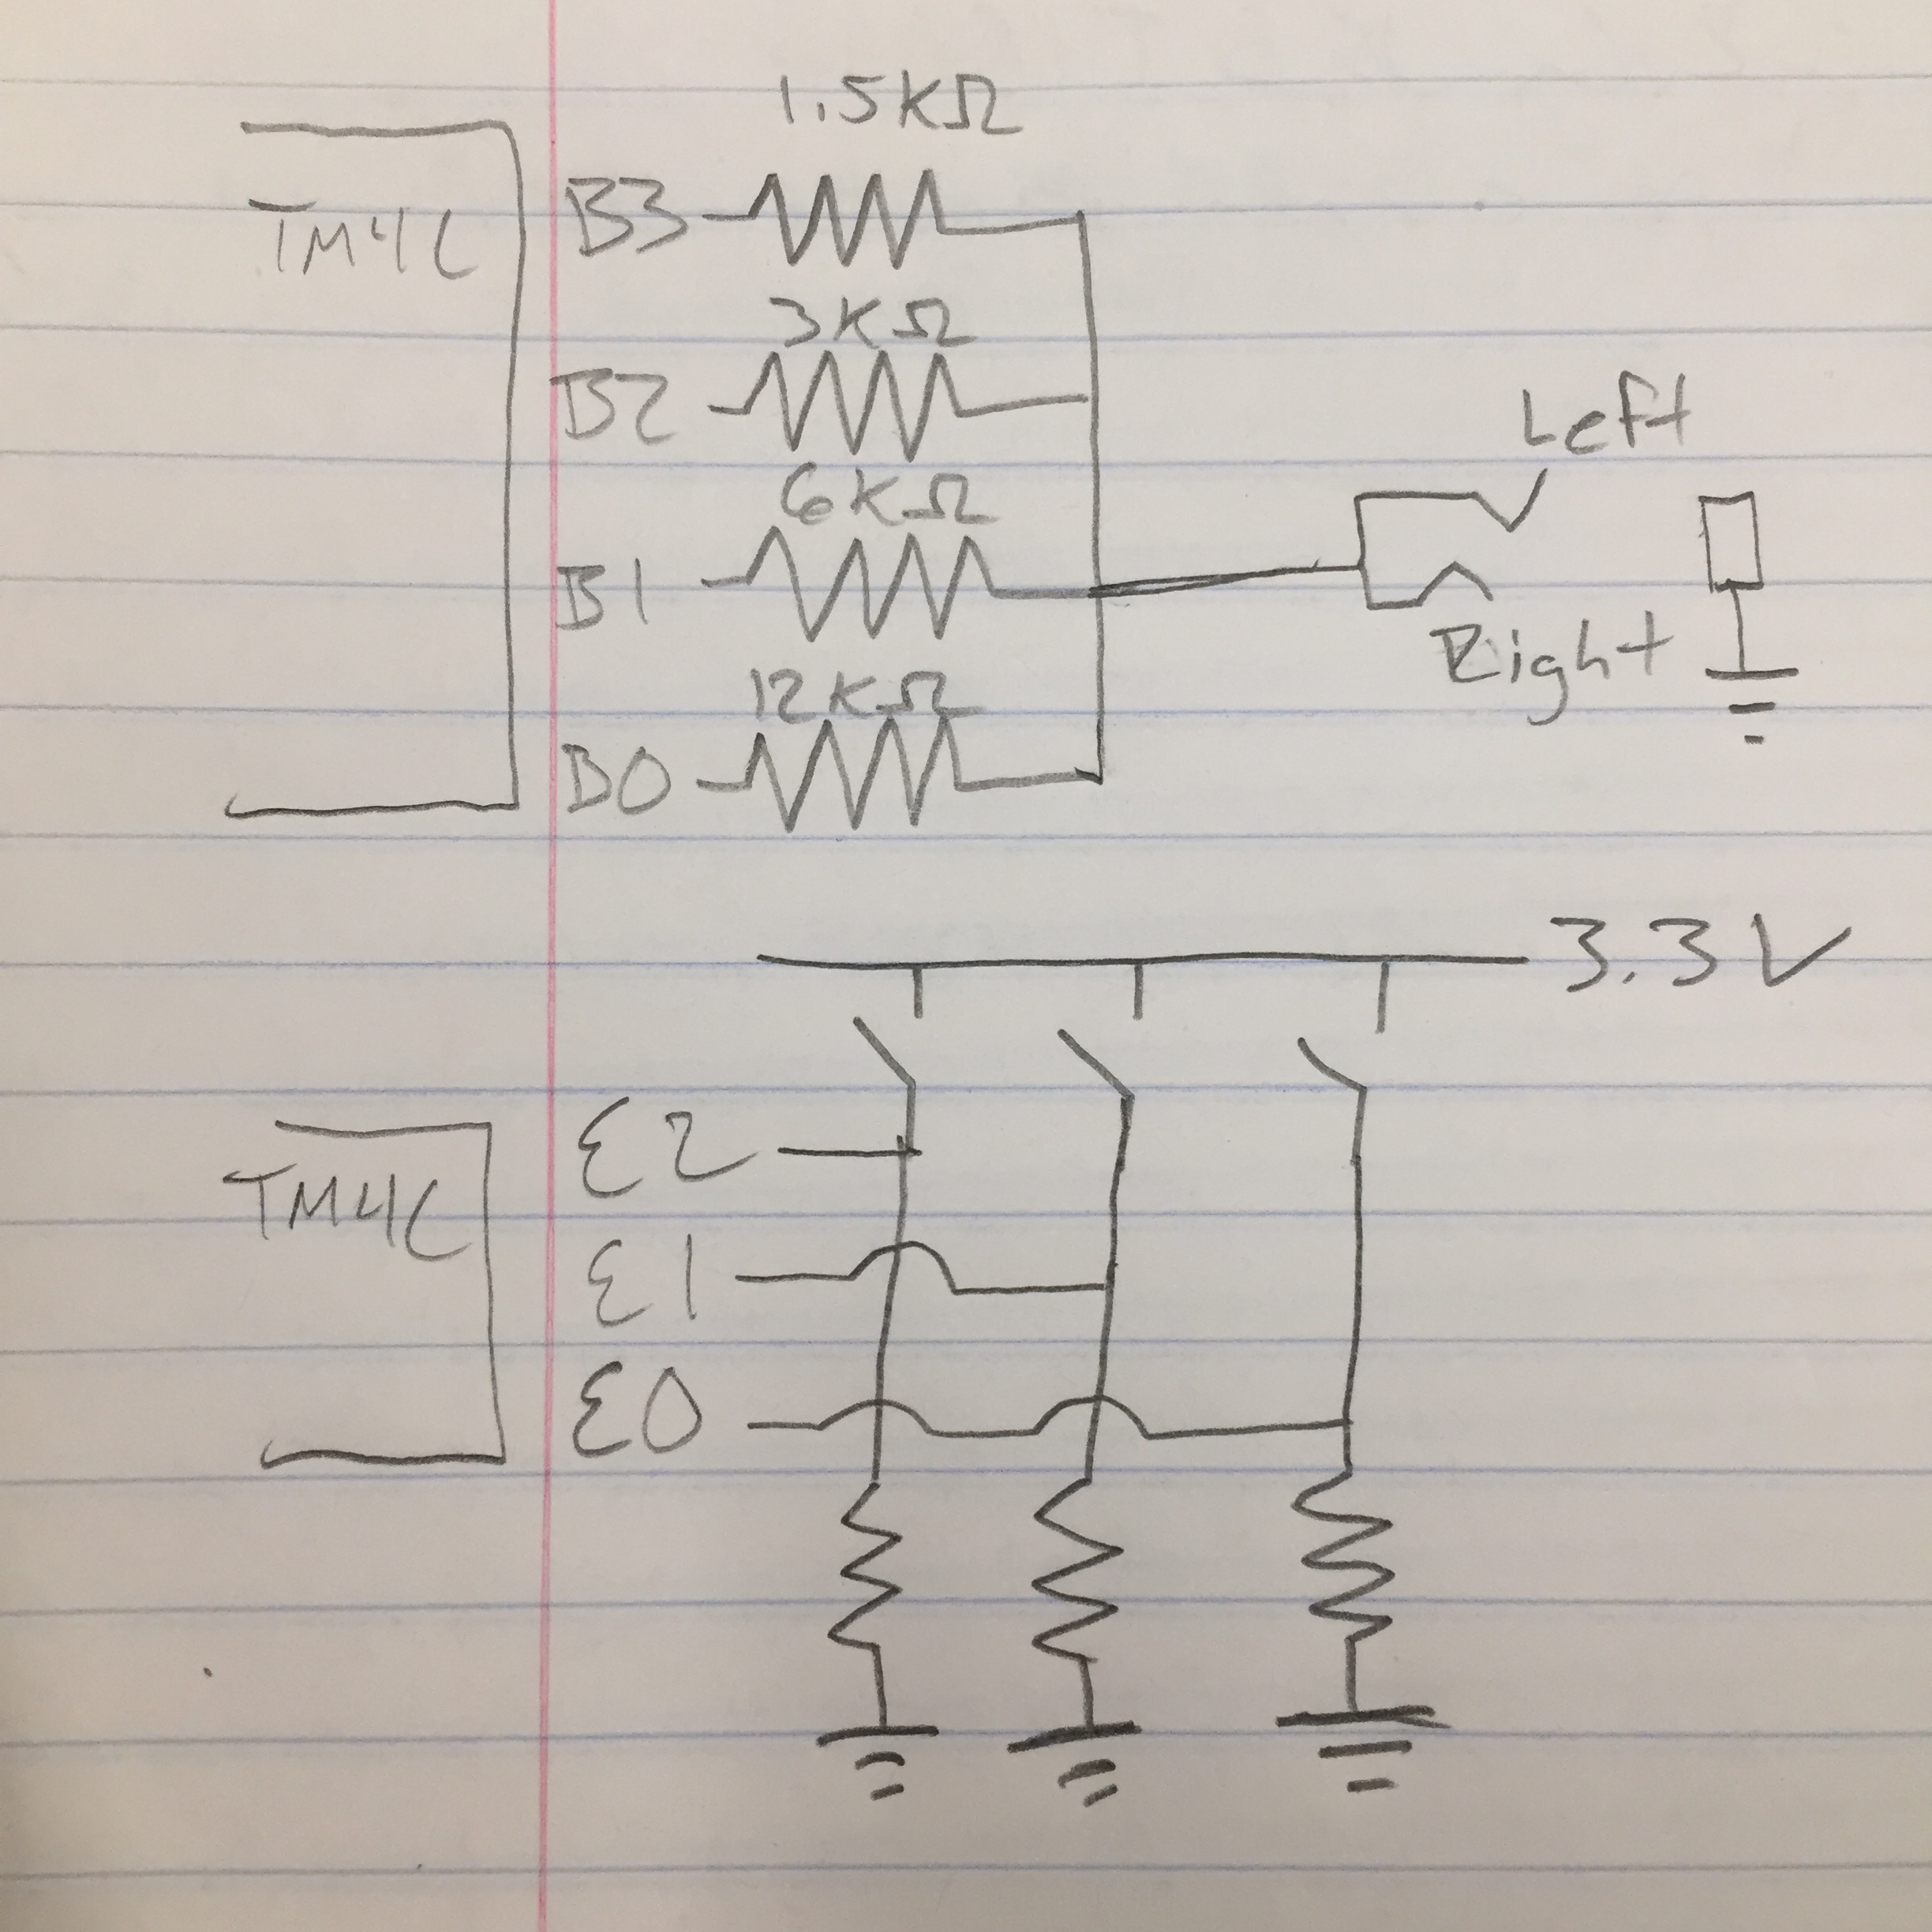

|  |  |
| --- | --- |
| 6 |  |
| 7 |  |
| 9 |  |
| 9 |  |
| 10 |  |
| 11 |  |
| 12 |  |
| 13 |  |
| 13 |  |
| 14 |  |
| 15 |  |
| 15 |  |
| 15 |  |
| 15 |  |
| 15 |  |
| 14 |  |
| 13 |  |
| 13 |  |
| 12 |  |
| 11 |  |
| 10 |  |
| 9 |  |
| 8 |  |
| 7 |  |
| 7 |  |
| 6 |  |
| 6 |  |
| 5 |  |
| 5 |  |
| 5 |  |
| 5 |  |
| 5 |  |
| 4 |  |
| 4 |  |
| 4 |  |
| 4 |  |
| 4 |  |
| 4 |  |
| 3 |  |
| 3 |  |
| 3 |  |
| 3 |  |
| 3 |  |
| 2 |  |
| 2 |  |
| 1 |  |
| 1 |  |
| 1 |  |
| 1 |  |
| 0 |  |
| 0 |  |
| 0 |  |
| 0 |  |
| 0 |  |
| 0 |  |
| 1 |  |
| 1 |  |
| 1 |  |
| 2 |  |
| 2 |  |
| 3 |  |
| 3 |  |
| 3 |  |
| 4 |  |
| 5 |  |

4) Oscilloscope

A Note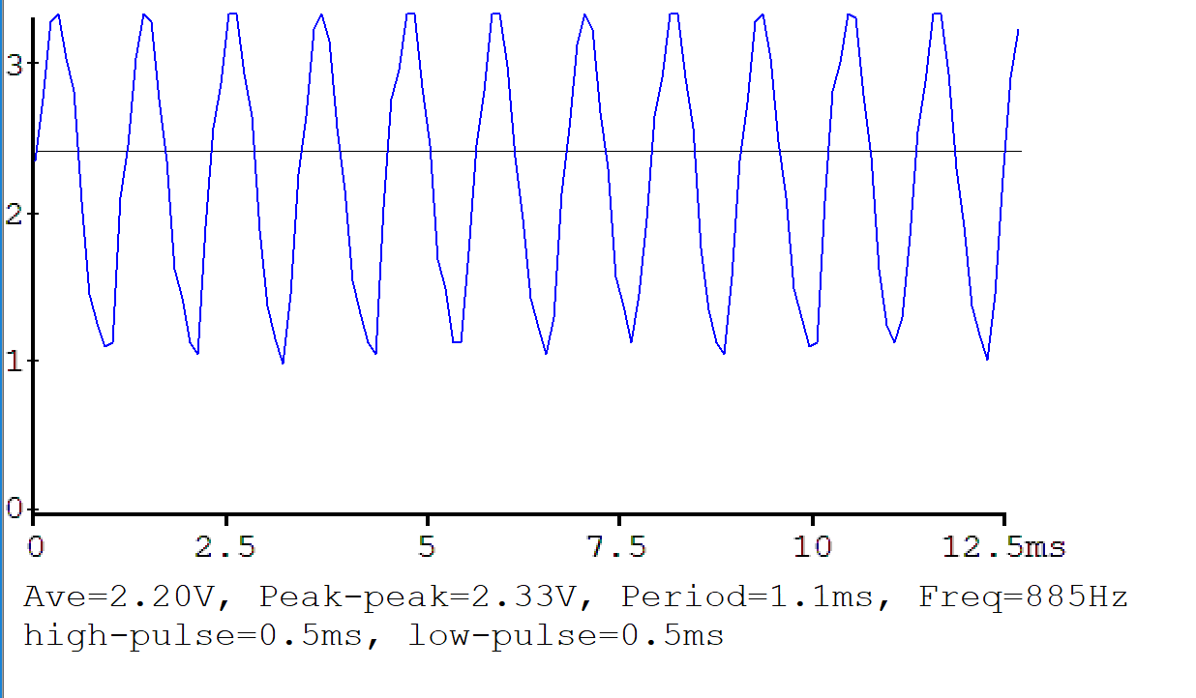

C Note

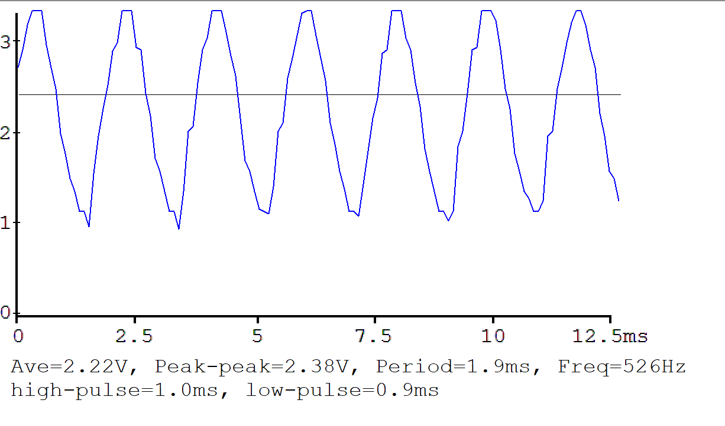

E Note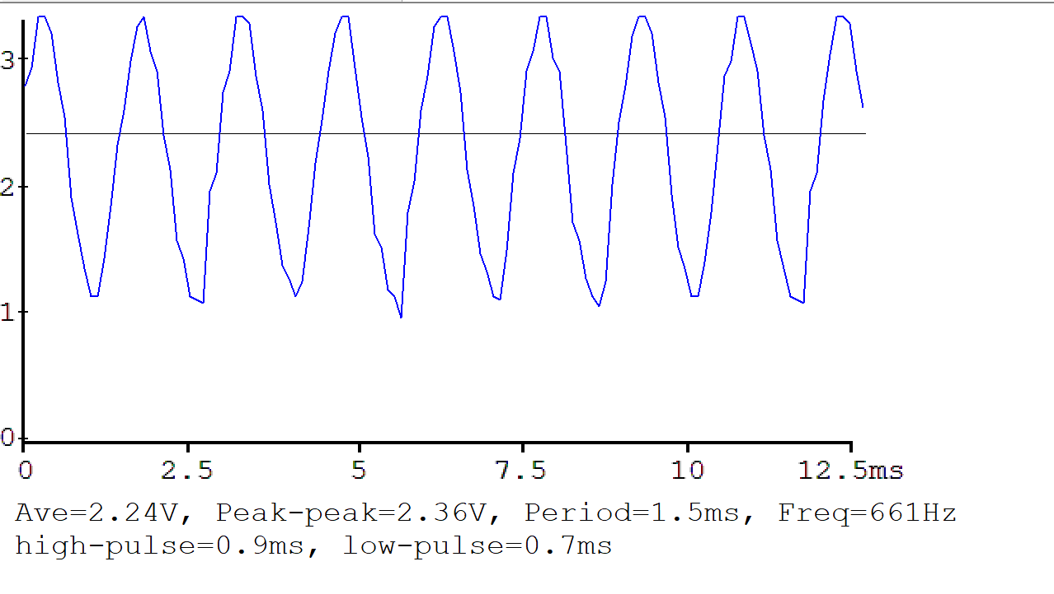

5) Measurement Data

|  |  |  |
| --- | --- | --- |
| Bits 3-0 | Theoretical (Volts) | Measured (Volts) |
| 1 | .22 | .233 |
| 2 | .44 | .464 |
| 3 | .66 | .697 |
| 4 | .88 | .877 |
| 5 | 1.1 | 1.110 |
| 6 | 1.32 | 1.341 |
| 7 | 1.54 | 1.574 |
| 8 | 1.76 | 1.718 |
| 9 | 1.98 | 1.951 |
| 10 | 2.20 | 2.181 |
| 11 | 2.42 | 2.413 |
| 12 | 2.64 | 2.610 |
| 13 | 2.86 | 2.829 |
| 14 | 3.08 | 3.054 |
| 15 | 3.30 | 3.282 |
| 0 | 0 | .001 |

6)

a)Interrupt occurs when SysTick Reload hits 0

b) The interrupt vector is in sound.c file

c) 1) Current instruction is finished,  
2) Eight registers are pushed on the stack,  
3) LR is set to 0xFFFFFFF9,  
4) IPSR is set to the interrupt number,  
5) PC is loaded with the interrupt vector

d) When an interrupt occurs, the address of the instruction that would have occurred next gets saved into the Link Register (LR), and once the interrupt is serviced, BX LR restores PC to the stored LR address and continues the program normally.